NewsletterWinter 2016

Winter 2016

Message from the Chair
Palos Verdes Peninsula Village is approaching its one year anniversary and exciting things are happening. We have moved into our new office at 916 Silver Spur Rd. in the heart of the Peninsula. We are able to host Board and Committee meetings, and Executive Director Colleen Cotter is meeting with those interested in joining, supporting or just learning more about the PVP Village. We now have a space to store our records and printed materials.
The Board of Directors is continuing its monthly meetings and working on a plan to sustain the Village for many years. This includes seeking funding and community support, increasing membership and engaging volunteers. We also are planning to expand the Board of Directors.
We continue to receive support and advice from Founding Director Sherry May despite her illness. We send her and her family our best wishes.
You will read in this Newsletter about the exciting programs we have hosted such as “A Conversation with Paul Irving and Helen Dennis” which attracted nearly 300 attendees. I believe we are making a positive impact in our community.
More programs are in the planning stages – watch your e-mail and the website for more information!
Fran Wielin

A Message from Sherry
I'm writing this a few days before Thanksgiving ... a special time when we gather as families and friends to remember what we have to be thankful for. For me this is a particularly poignant time this year.
Since I was diagnosed in August with an incurable cancer, I have been overwhelmed with the outpouring of love and support from so many Village friends. Your cards, e-mails, responses to Caring Bridge, gifts, and visits brighten my days and remind me of the importance of being part of a community.
Thank you.
Sherry
Sherry

COMMENTS FROM COLLEEN
Hello Village Members,
I can’t believe that it is December! Time is flying by here at the new PVP Village office. We have 70 members and an incredible team of volunteers who always answer our requests for help. In the past 11 months, we have had over 200 requests. Most are for transportation, but we have also assisted members with IT issues, minor home repairs, friendly home visits referrals and more. Thank goodness, we have been able to fill every request so far. Our volunteers are so kind, giving and generous with their time.
The PVP Village and Providence Little Company of Mary met on November 4th for our first MedPal training. Twenty-one members/volunteers learned about the importance of being prepared for a doctor’s appointment: a Volunteer will meet with a member before an important doctor’s appointment, take notes of questions and concerns to address to the doctor, record medical details at the office if requested to do so, and help with follow-up needs thereafter. We are very fortunate to have incredible backing and dedication from Providence Little Company of Mary Medical Center.
Board member Steve Jordan has taken over the organization of our Programs. He is very excited about starting a men’s group and other fun events. Read more for information about upcoming plans for the PVP Village. All of our pending events will be listed on our website calendar. Please be sure to check it out.
I hope to see you all very soon and from my home to yours, we send you tremendous amounts of joy and laughter this season.
Colleen
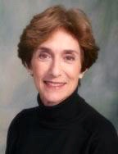
Our own Helen Dennis was chosen by Next Avenue (a journalism service for America’s older population) as one of the “2016 Influencers in Aging”. There were 50 advocates selected: researchers, thought leaders, innovators, writers and experts who continue to push beyond traditional boundaries and change our understanding of what it means to grow older.
When asked by Next Avenue, “IF YOU COULD CHANGE ONE THING ABOUT AGING IN AMERICA, WHAT WOULD IT BE,” Helen responded: "I would eliminate ageism, the only remaining socially acceptable 'ism.'
Ageism is a barrier to employment and to sufficient funding for age-related diseases. It reinforces adults’ negative self-fulfilling prophesy. Without ageism, wisdom would be sought after; employment opportunities would be equal and older adults, our most underutilized resource, would have greater opportunities to fulfill their potential and live a life of purpose and dignity. We’ve come a long way, but not far enough or fast enough."

Kudos
Helen Dennis
2016 Influencers in Aging

Do You Know What Our Members and Volunteers do for the Village?
They support our website……Publish the Newsletter……Plan, host and facilitate programs……Work on fundraising……Write birthday cards…..Train as MedPals….Help with computers….Assist with minor home repairs, make friendly visits AND very importantly transport members to medical appointments, grocery shopping and other activities.
As it has been said many time times “IT TAKES A VILLAGE!”

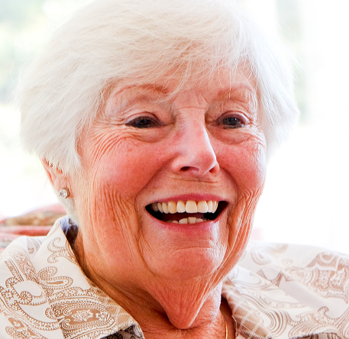
LINDA LOCONTE - VOLUNTEER EXTRAORDINAIRE
Linda has lived in her lovely Rancho Palos Verdes home for 41 years. She was born in Oklahoma and moved to San Jose, California when she was four years old. She has lived in Southern California since the age of fourteen. After a varied career, Linda took over her father’s liquor store, Farmers Liquor, in Gardena. Later, because of her great fondness for animals, she tried house/pet sitting. That didn’t turn out quite so well as Linda hoped it would when one of her charges ran away while under her care!

Helping others, however, has always been an essential part of what defines her. Linda has served on the Board of Pacific View, her Neighborhood Homeowners Association, as treasurer. Additionally, she welcomed new neighbors, planned the yearly social get together, and served as Neighborhood Watch and Emergency Preparedness block captain. She worked at PV Resale where her hours earned a donation to Meals on Wheels in the Torrance/Lomita area; she assisted at House of Hope, a recovery center for women, where she transported residents to the shopping center for needed supplies; and today, Linda is a dedicated volunteer with the Palos Verdes Peninsula Village.
Linda learned about the Village Concept from a talk by Brian Williams. He inspired her; she believed that what he said made sense. She attended an initial meeting of the PVP Village and was impressed enough to sign up as a volunteer. Since then, she has been a wonderful help to several of our Village members. She enjoys driving a Villager to her weekly appointment after which they enjoy a pleasant lunch together. She has helped a member who was hospitalized by checking on her home, watering, and most importantly picking up phone messages. One of the calls was from a long time friend of the person in the hospital who was worried sick because her messages were not being returned. Linda was able to contact the caller and explain what had happened to her friend, much to the relief of all.
Linda plays golf on Thursdays with her “Hit and Giggle” group at golf courses all around Southern California. Travel mostly involves family gatherings. Of special note was an African Safari with her niece, which, Linda added enthusiastically, was extraordinary. She also delights in musical theater, most recently attending “It’s Beautiful” with Carole King.
Linda epitomizes the essence of the Palos Verdes Peninsula Village, the spirit both of giving and receiving. She is a devoted volunteer; her enthusiasm is contagious, her smile infectious. Thank you Linda, and thank you to all of the volunteers who make our Village such a wonderful community.

VILLAGE TO VILLAGE NETWORK CONFERENCE
The PVP Village is a member of the Village-to-Village Network, a national organization of 200 operating villages. Headquartered in St. Louis, the Network works to maximize the growth, impact and sustainability of individual Villages and the Village movement.
On October 17-19, five of our Villagers attended the 2016 conference held in Columbus, Ohio. Colleen Cotter, Executive Director, was our official representative. Fran Wielin, Steve Jordan, Margi Braun and Maria Ashla volunteered at their own expense to join her. All were inspired and informed by the speakers, lectures, workshops on age-friendly communities, reports on research by UC Berkeley, and strategic planning for the future.

THE UPSIDE OF AGING* WITH HELEN DENNIS AND PAUL IRVING
CELEBRATING THE PALOS VERDES PENINSULA VILLAGE
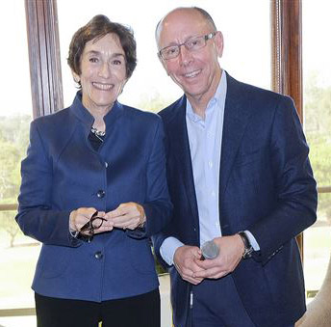
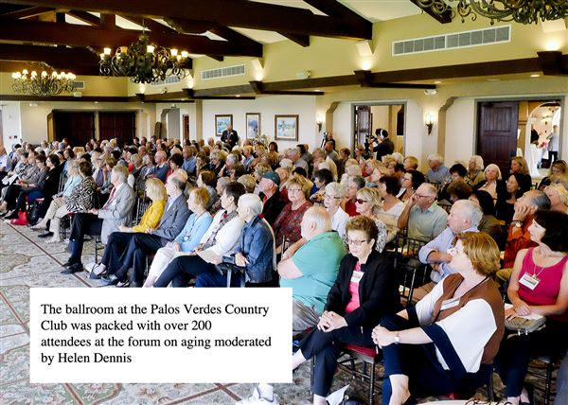
Full capacity attendance

Helen Dennis & Paul Irving
On October 13, 2016, 300 people gathered at the Palos Verdes Golf Club for a conversation with Paul Irving, author of “The Upside of Aging.” Helen Dennis, Village Board member, columnist, author and lecturer lead the conversation with Irving. The topic was perfect since the Village capitalizes on the upside of aging while acknowledging and responding to the challenges. That upside means emphasizing independence as well as interdependence, staying connected, growing intellectually, emotionally and socially – all with grace, humor and caring.
Here are a few highlights of the conversation:
- Greatest challenges: Climate change and global aging.
- We have the power to change our course when it comes to aging.
- Purpose is important. A Yale study indicated that older adults in the study who have a sense of purpose lived seven years longer than those with little or no purpose.
- Words matter; language is important. Everyone who wants to change aging needs to talk about it in different ways.
- We have the gift of longevity. If we ignore this change we are missing a valuable opportunity to engage a significant human resource that can help shape a better future.
- Older adults are drivers of the economy. They contribute $7 trillion which now is considered the longevity economy.
- We are making changes on regional levels.
- We are in a new life stage. It’s so new we can’t find the right words for it. Some call it retirement, elderhood and senior citizen. Others refer to it as the encore time of life.
- Ageism is an impediment to change. We need to re-imagine aging and change our cultural perspective.
- Older adults are an untapped resource and a valuable source of human capital. It’s more than their wisdom; it’s their practical experience and skills that enrich work, educational and social settings. They mentor, train in the work place and enhance relationships between the generations.
- * Based in part on the Village conversation with Paul Irving and a similar interview with Irving as reported in the Quarterly Journal of the Life Planning Network, Summer 2016, Volume 3, Issue 3.

INTEREST GROUPS FORMING
The PVP Village is forming Interest Groups that will be member-organized and will meet on a regular basis. The leader will maintain a list of group members and will communicate directly with the group to schedule meetings and work out other details.
ANY IDEAS? – WE NEED YOUR INSPIRATION AND IMAGINATION -
Any member who has a good idea and would like to organize a group, please call Judy Purvis at 310-375-8578 or email her at bjpurvis@cox.net for assistance in recruiting members.
Groups already forming:
Salon - Norm Zareski. This group, not afraid of controversy, has met monthly and discussed current topics of interest. Check calendar for dates
Men’s Group - Steve Jordan
Book Group - Kathleen Fitzgerald - will meet in January to decide on format and book preferences
Knitting Group - Margi Braun is in the process of finding out if there is enough interest
Walking/strolling Group - (Looking for leader, organizer)
Lunch or Breakfast Group - (Looking for organizer)
all are

HERE’S A TASTE OF STEVE JORDAN’S IDEA:
MEN OF A CERTAIN AGE - That’s us, the guys who are members and/or volunteers with the Palos Verdes Peninsula Village.
You all are invited to an evening of good cheer on Saturday, December 10th from 5-7 pm at the home of Norm Zareski 1725 Dalton Road PVE. We are going to do a blind vodka tasting, watch a “travelogue” to Russia by Hal Lazar, and enjoy appetizers and homemade chili. You don’t need to bring anything except your discriminating palettes and a good appetite.
Please RSVP to Steve Jordan by Wednesday December 8th so we can get a head count. sejmjb@hotmail.com or 310 365-4380. If you need a ride let me know and we will make that happen.

SAVE THE DATES:
“ADVANCE CARE PLANNING FOR SMARTIES”
Jan. 10, 17, 24 1:00 – 2:30pm Peninsula Library Community Room
Presenter; Ed Long, Retired Attorney; Founder of H.E.L.P, Founder and Director of Caring House, and advisor to the Board of the Palos Verdes Peninsula Village.
We will share ways to think about our preferences for care and how to communicate those wishes to family members and caregivers who might be responsible for our health decisions in the future. Also we will discuss the necessary documents in plain language.

WHAT ELSE HAS BEEN GOING ON? Below is just a sample
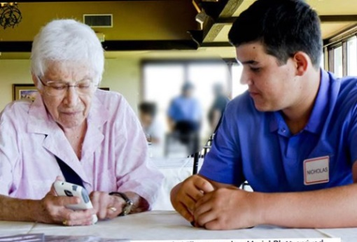
IT HELP and Lunch at the Red Onion October 28th – Peninsula HS Students assisted PVP Village members with technology questions

MUSIC AL FRESCO at the home of Bob and Rose Bohner
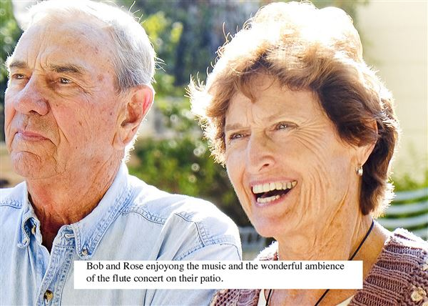

Bob and Rose Bohner

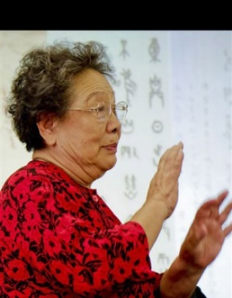
CHINESE CULTURE LECTURES BY DOCTOR TERESA SUN
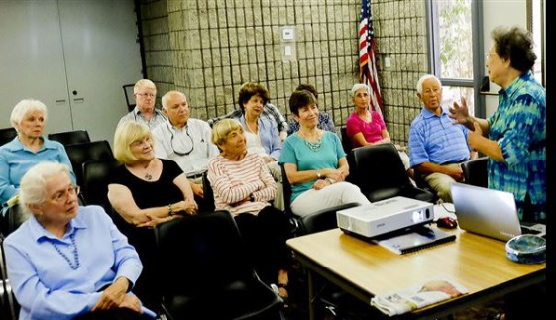
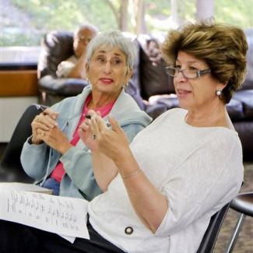

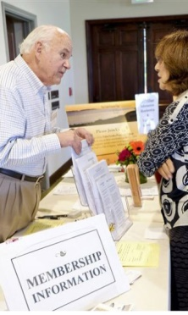
INTRODUCING OTHERS TO THE VILLAGE AT THE UPSIDE OF AGING EVENT
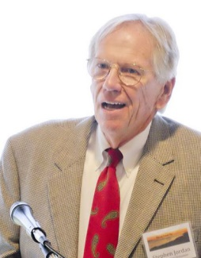

MARK YOUR CALENDAR
DECEMBER
Dec. 7 10am-1pm | Holiday Party - Home of Susan Wallace
Dec. 9 10-11am | Coffee with Colleen PVPV office
Dec. 10 5-7pm | Men’s Club Vodka Tasting Home of Norm Zareski
JANUARY
Jan. 9 3-5 pm | Charter Member & Donor Party, PVPV Office
Jan. 10, 17, 24 1-3pm | Ed Long Talk,…Peninsula Center Library
Jan. 13 11 am | IT Help, Peninsula High School
Jan. 18 1-3 pm | Adia presents “Shake Out – get ready” Hesse Park
Jan. 27 5-7 pm | Salon Location TBD
Jan. 28 10 – 12 noon | IT Help - Peninsula Library (open to the community)
Jan. 30…2-4pm | Volunteer Party Peninsula Library Community Room
FEBRUARY
Feb 4 2-4pm | One Book One Peninsula “Queen Sugar”  Author Natalie BazileBook signing and discussion Botanic Garden
Feb 7 2-4pm | Bruce Juell Retirement Activities Guide Location TBA
Feb 10 10-11am | Coffee with Colleen PVPV office
Feb. 13 1-3:30 pm | Celebrating with Beacon Hill Village and 15 year Village Movement  Peninsula Library
Feb. 15 & 22  1-2:30pm | What I need to know about Dementia Hesse Park
Feb. 24 10-12noon | Salon Location TBD
MARCH
March 1 1-2:30pm | Transportation Talk “On the move riders club” Hesse Park
March 8 | L.A. Outing Details TBD
March 10 10-11 am | Coffee with Colleen PVPV office
March 17 10 – 12noon | IT help --Bring your questions and computer/cell phones. Peninsula High School
March 24 5-7pm | Salon Location TBD
March 29 1-2:30pm | Innovations in home health care Sheridan Home Health Care Hesse Park

Palos Verdes Peninsula Village
916 Silver Spur Road - Suite 302
Rolling Hills Estates, CA 90274

